Class
Days
FIRST PRESBYTERIAN PRESCHOOL OF BRANDON, INC.

ENROLLMENT FORM--2023/2024

CHILD’S NAME:_________________________________________________________DATE ENROLLED:___________________

NICKNAME:_____________________________DOB:___________________________GENDER (circle one): MALE FEMALE

ADDRESS:______________________________________________CITY:__________________________ZIP:_________________

MOTHER’S NAME:______________________________________FATHER’S NAME:____________________________________

HOME PHONE:__________________________________________HOME PHONE:______________________________________

CELL PHONE:___________________________________________CELL PHONE:_______________________________________

EMPLOYMENT:_________________________________________EMPLOYMENT:______________________________________

WORK PHONE:__________________________________________WORK PHONE:______________________________________

EMAIL ADDRESS:___________________________________________________________________________________________

CUSTODIAL PARENT (circle one): MOTHER FATHER JOINT
_ _ _ _ _ _ _ _ _ _ _ _ _ _ _ _ _ _ _ _ _ _ _ _ _ _ _ _ _ _ _ _ _ _ _ _ _ _ _ _ _ _ _ _ _ _ _ _ _ _ _ _ _ _

PERSONS AUTHORIZED TO REMOVE CHILD FROM SCHOOL (IDENTIFICATION REQUIRED) (other than parents)

1. _________________________________________________________________________________________________________
NAME RELATIONSHIP PHONE

2. _________________________________________________________________________________________________________
NAME RELATIONSHIP PHONE

3. _________________________________________________________________________________________________________
NAME RELATIONSHIP PHONE

4. _________________________________________________________________________________________________________
NAME RELATIONSHIP PHONE

HILLSBOROUGH COUNTY ORDINANCE requires your signature acknowledging the receipt of the following:

- KNOW YOUR CHILDCARE FACILITY brochure
- DISCIPLINARY PRACTICES & PROCEDURES and EXPULSION POLICY
- INFLUENZA VIRUS brochure
- DISTRACTED DRIVER brochure
- I understand that I must provide a current HEALTH EXAM (form 3040) and IMMUNIZATION RECORD (form 680/681) within 30 days of enrollment

_______________________________________________
Signature of Parent or Legal Guardian
(Please continue to other side)

Medical Alert Information (ie: allergies, medical and/or handicapping conditions):________________________________

__________________________________________________________________________________________________

Alternate Nutrition Plan/Special Dietary Requests:_______________________________________________

_______________________________________________________________________________________________________

Additional information which would be beneficial for the preschool staff to know about your child:__________________

__________________________________________________________________________________________________

Child’s Physician:_________________________________________Telephone:_________________________________

Physician’s Address:_________________________________________________________________________________

Preferred Hospital:__________________________________________________________________________________

_ _ _ _ _ _ _ _ _ _ _ _ _ _ _ _ _ _ _ _ _ _ _ _ _ _ _ _ _ _ _ _ _ _ _ _ _ _ _ _ _ _ _ _ _ _ _ _ _ _ _ _ _ _ _ _ _ _ _ _ _ _ _ _ _

EMERGENCY CONTACT (other than parents)

1. _______________________________________________________________________________________________
NAME RELATIONSHIP TELEPHONE

2. _______________________________________________________________________________________________
NAME RELATIONSHIP TELEPHONE

3. _______________________________________________________________________________________________
NAME RELATIONSHIP TELEPHONE

_ _ _ _ _ _ _ _ _ _ _ _ _ _ _ _ _ _ _ _ _ _ _ _ _ _ _ _ _ _ _ _ _ _ _ _ _ _ _ _ _ _ _ _ _ _ _ _ _ _ _ _ _ _ _ _ _ _ _ _ _ _ _ _ _

AUTHORIZATION FOR EMERGENCY MEDICAL TREATMENT

If my child, _____________________________________, should become ill or injured at First Presbyterian Preschool of
Brandon, I understand that the school staff will: (1) Contact me immediately or, (2) Contact the person(s) I have
designated if I cannot be reached.
Should the school staff be unable to reach me and/or the person(s) designated, they are authorized to contact my child’s
physician and/or arrange for immediate medical treatment. The physician and/or medical facility are authorized to
administer emergency medical treatment as necessary to ensure the health and safety of my child. I will accept
responsibility for payment for medical services rendered.

________________________________________________________________________________________________
SIGNATURE RELATIONSHIP DATE

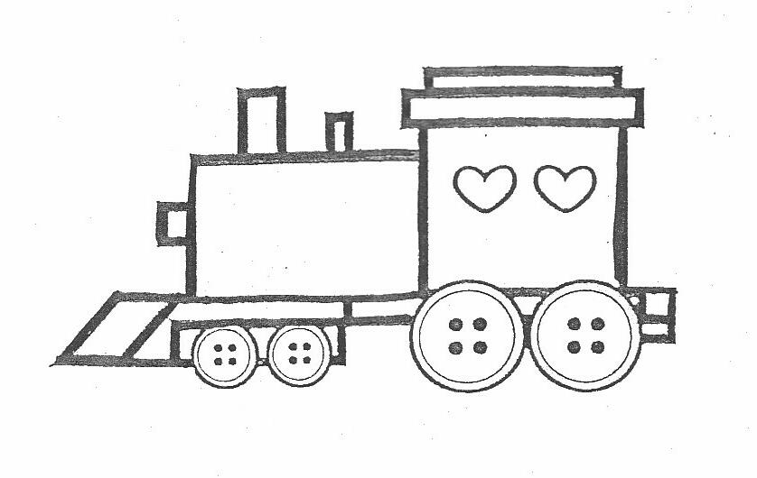
FIRST PRESBYTERIAN PRESCHOOL OF BRANDON
121 Carver Avenue, Brandon, Fl 33510 813-689-0947 • Lic.#CHC110377
__________________________________________________________________________________

Dear Parents:

As part of our curriculum, we conduct Observational Checklists with your child twice each year. This is not a Professional Education Screening. We use these checklists to evaluate your child’s developmentally appropriate progress, and to tailor our lesson plans to meet individual needs. Teachers will share these observations with you as they are completed in October and May.

Please sign and return the following parent consent form allowing First Presbyterian Preschool to complete the Observational Checklist for your child.

Sincerely,

Lynn Bruner, Director

-----------------------------------------------------------------------------------------------------------------------------------

Parent Consent Form for Observational Checklist

I, _______________________, grant First Presbyterian Preschool of Brandon permission
Parent’s Name

to conduct an Observational Checklist with my child, _____________________________.
Child’s Name

__________________________________________ ________________________
Parent’s Signature Date

FIRST PRESBYTERIAN PRESCHOOL OF BRANDON
121 Carver Avenue, Brandon, Fl 33510 813-689-0947 • Lic.#CHC110377
__________________________________________________________________________________

Media Release:

By signing this release, I give permission for First Presbyterian Preschool of Brandon to

photograph and/or videotape my child, ____________________________________ in the

classroom or at school/church events. I understand that these photographs/video may be:

- displayed on bulletin boards within the facility
- displayed at special school/church events
- printed in our school yearbook
- provided to preschool families only in hard copy
- included on CD’s or DVD’s for distribution to preschool families only
- used on First Presbyterian Church’s website
- used on First Presbyterian Preschool’s Facebook page

Please indicate your consent by signing below.

Media Release Form

I, _____________________________, give First Presbyterian Preschool of Brandon permission
Parent’s Name

to photograph or videotape my child, _________________________________, and use them
Child’s Name

as described above.

__________________________________________ ________________________
Parent’s Signature Date

