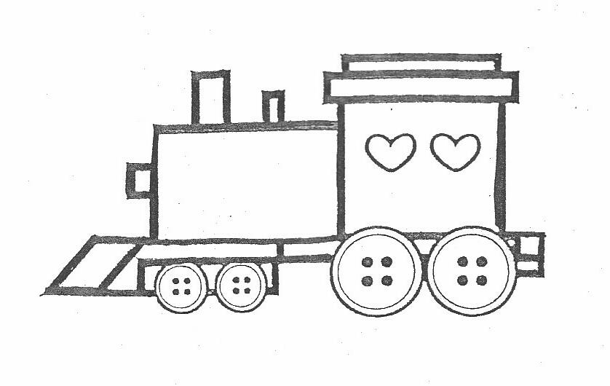
FIRST PRESBYTERIAN PRESCHOOL OF BRANDON
121 Carver Avenue, Brandon, Fl 33510 813-689-0947 • Lic.#CHC110377
__________________________________________________________________________________

VPK Attendance Contract

Students enrolled in our VPK program must understand and adhere to regular attendance policies as set forth by the State of Florida as follows:

- My child will attend the VPK Program a minimum of 80% of school days each month (ie: in a month of 21 school days, student must attend 17.)

- I will sign documentation each month confirming my child’s attendance.

- I understand that the VPK school calendar varies from the First Presbyterian Preschool calendar for younger students.

- Participation in school programs outside of VPK hours are voluntary and I agree to pay applicable fees. (ie: Early Drop Off or Lunch Bunch)

- If termination from the VPK program occurs due to the inability to adhere to this contract, I will have the option of keeping my child enrolled and paying the regular tuition rate.

I understand that failure to comply with these guidelines may result in my child being withdrawn from the VPK program.

_____________________________________
Child’s Name

__________________________________ _______________________________
Parent’s Name Parent’s Signature

_________________
Date

